Uploading course outline in LMS courses

1. Access LMS website https://lms.nust.edu.pk/

2. Login to LMS portal.

3. Click on “Turn Editing On” Button.

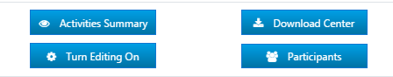

Display of the Course Outline:

4. In the first section of the course, course outline related label activities are available, which need to be updated using the respective “Edit > Edit settings” option.
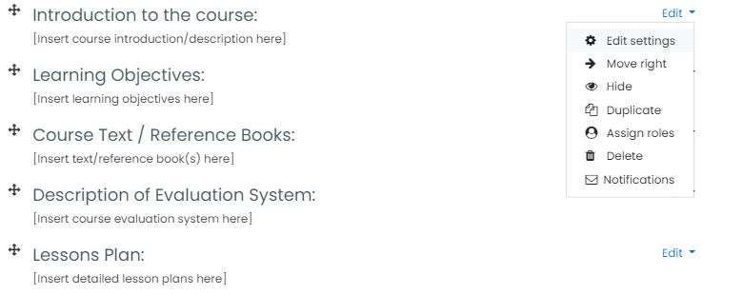

5. Replace the default label text with the course specific details in connection with the title of the label such as Introduction to the course, Learning objectives etc.

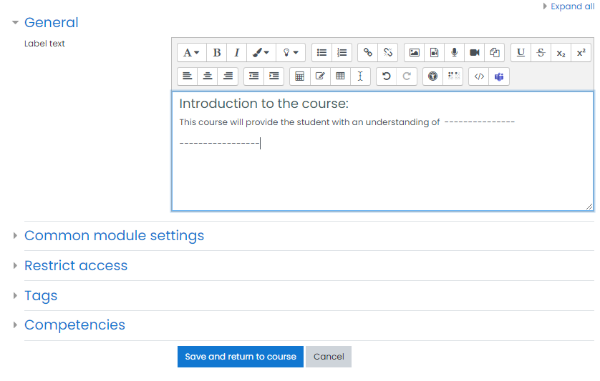

6. Save and return to course after updating the label.

7. Repeat the process for all label activities relating to the course outline.

Uploading Course Outline Document:

In addition to displaying the various sections of course outlines on the LMS course page, the complete course outline document is also required to be uploaded in the course.

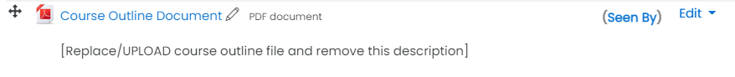

8. Click on the “Edit > Edit Settings” for “Course Outline Document” resource available in the course after label activities. Make sure the resource “Name” in “General Section” includes the string “Outline” in it. However the course code, name etc can be added in this field.

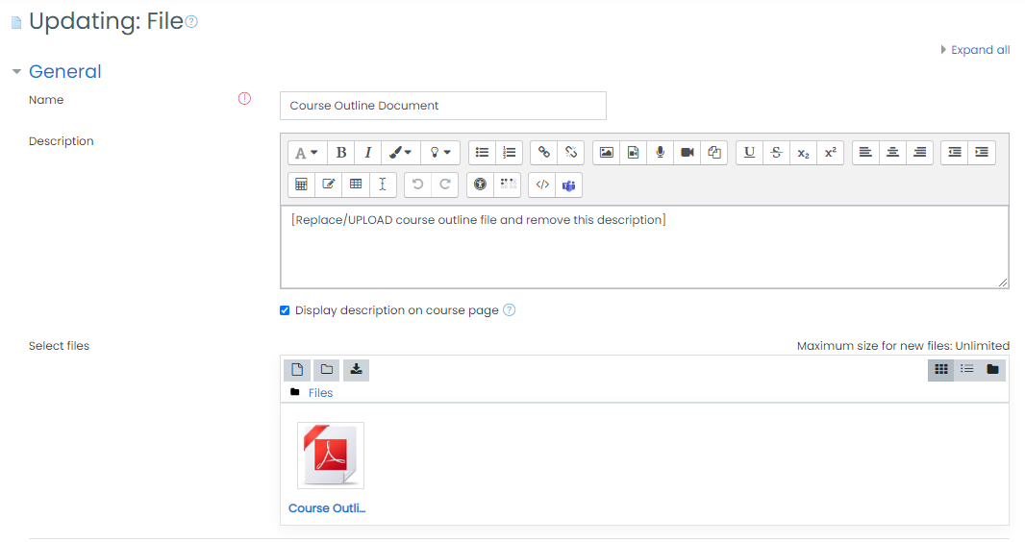

9. Remove the default description i.e. Replace/UPLOAD course outline file and remove this description, from the “Description” text box.

10. Replace the existing template course outline template PDF file (already available in this resource) with the actual course outline document. The course outline document can be uploaded using file picker or drag and drop.

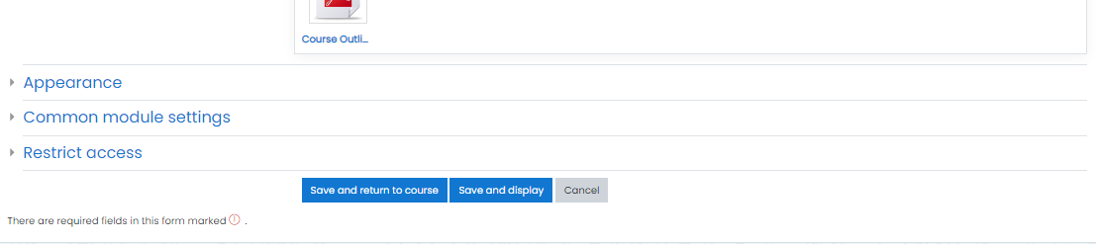

11. Save and return to the course.

_______________________________________

